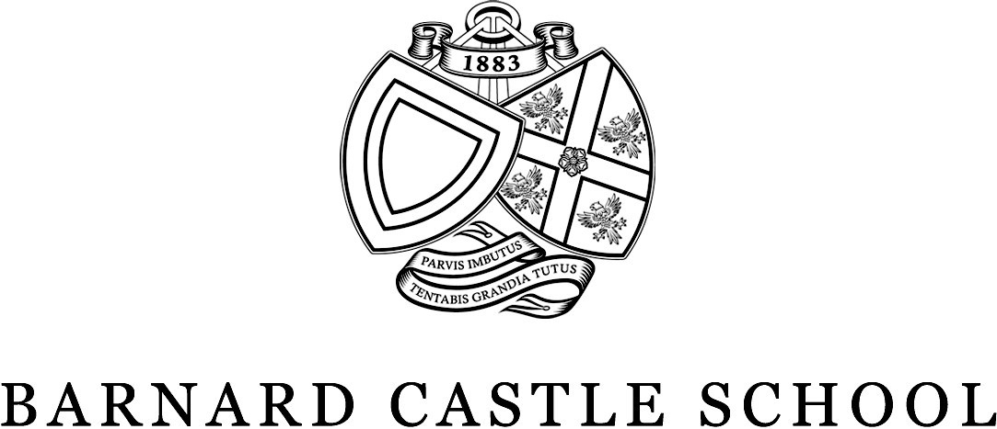

Medical Care
Introduction
Barnard Castle school is an inclusive community that seeks to support pupils with their health and wellbeing. The school empowers pupils to engage in school activities appropriate to their ability and any medical conditions. Where indicated, the nurse team will implement individualised care plans to facilitate this and ensure the pupil’s health needs can be met.

Medical Centre
The Medical Centre is staffed by nurses and is open from 8.00am – 5.00pm Monday to Friday and 8.30am – noon on Saturdays. Nurses assess children and treat them for minor medical complaints and accidents and injuries. The nurses will determine if the medical need requires escalation to a GP, urgent care or A&E. They can also arrange for access to other NHS services as required.
When the medical Centre is closed, any students needing care are assessed by boarding staff who are trained in basic first aid, treatment of minor conditions, emergency managements of common complaints, and administration of medication. If they require further advice, they will utilise NHS services such as 111 or 999.
Barney School recognises the importance of communication with parents/ guardians regarding medical matters, and parent/ guardian input is welcomed to ensure that the most appropriate care is delivered to all pupils.

Medical Card
On admission, parents/ guardians are asked to complete a medical card for the school. This needs to be completed and signed before the student arrives. These forms are essential to communicate a student’s medical condition, any allergies and/or food intolerances, and to provide consent for nurses to administer medications and first aid. Medical records, including the medical card, are stored securely in the medical centre. Medical information is accessible to the school nurses and only shared with the GPs and other staff as needed to best care for the student.

Access to a GP
Flexi-boarding and day pupils will be registered with their own family GP.
In addition to being asked to complete a Medical Card, Parents/ guardians of full-time boarders are asked on admission to complete a GP registration form (GMS1). Once received, pupils are registered with Barnard Castle Surgery and can utilise the practice for the provision of general medical services.
A GP from Barnard Castle Surgery contacts the medical centre daily, Monday – Friday, between the hours of 10am and 11am to discuss medical matters with the school nurses. When indicated, telephone or face-to-face GP consultations can be arranged for boarder students. Typically, these appointments are available in 1-2 days.

Medical Examinations and Annual Reviews for Chronic Conditions
During their first term, all new boarders will receive an orientation to the medical centre and a medical examination from the school nurse. Students with chronic conditions that would be managed by the GP Practice rather than a consultant (e.g. asthma) are reviewed by the practice annually.

Illness
While every effort is made to keep students in school, if a day pupil is very unwell, the school nurses will contact parents and ask parents to collect their child. If a boarding pupil becomes unwell, they will be assessed at the medical centre and, if indicated, a GP appointment will be made. Boarders too unwell to return to school are typically able to rest in their room and will be monitored by house staff and/or nurses.

Emergency Medical treatment
In a medical emergency, efforts will be made to contact a parent/ guardian. However, if they cannot be reached, the school has the authority to act on the advice of an appropriately qualified medical specialist to initiate emergency care.

Gillick Competence
Fraser guidelines, more commonly referred to as Gillick Competence is used in medical law to decide whether a child (16 years or younger) is able to consent to his or her own medical treatment, without the need for parental permission or knowledge. A child will be Gillick competent if he or she has sufficient understanding and intelligence to understand fully what is proposed. They also have the right to request confidentiality and ask that a parent not be informed. While staff will always encourage students to talk to parents, we are required to respect the rights of pupils to make independent choices.

Medication brought to School by pupils
Pupils bringing medications to school must notify either he day matron (boarders) or the nurses. If a day pupil requires prescribed medications to be administered throughout the school day, parents should complete a ‘Request for administration of medicines’ form.

Routine Medical Appointments
Parents are encouraged to organise dental, orthodontic, optometric, physiotherapy and other specialist services in the school breaks. However, this is not always practical espevially for international students. For boarders needing appointments in school term time, we can arrange for house staff to take them. Sixth form pupils may attend the appointment alone.

Immunisations and Travel Vaccines
School age child vaccinations are offered by the regional Immunisation Team who come onsite to administer Influenza, HPV, Meningitis ACWY and the Diphtheria/ Tetanus/ Polio (DTAP) vaccines. They may also administer Covid vaccines when recommended. Parental consent will be sought prior to any vaccination session.
Travel vaccinations which are required by boarders will be arranged through the Barnard Castle Surgery or a travel clinic on request and with parental consent.

