GUIDANCE FOR COMPLETING MEDICAL FORMS

All new students need to have a Medical Card completed and returned before prior to the start of term.
The Medical Card should be completed in full (3 pages), and the consent must be signed for the pupil to be able to receive medications and first aid treatment.

If the student is a boarder, they also need a completed GP Registration Form (GMS1). This is needed for them to be registered at the local GP practice. Without it, they cannot access NHS services. Once registered, students receive an NHS number which can be used all over the UK.

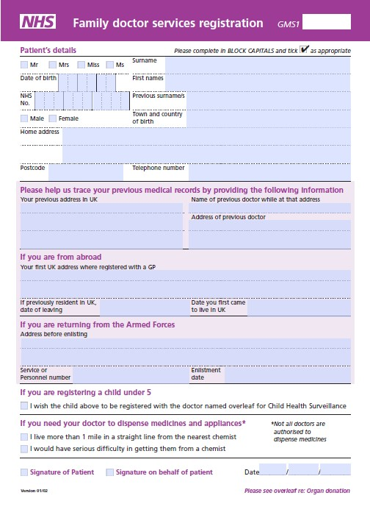

The Home address on this form should be the school address:
Barnard Castle School
Newgate
Barnard Castle
DL12 8UN
01833 690222
If the student hasn’t previously lived in the UK or previously used NHS services, this address will be the first UK address.

Please sign the form.

