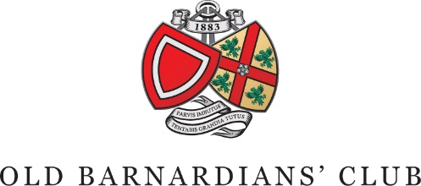
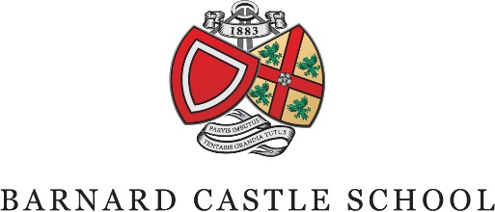

June 2022

‘Once a Barnardian, always a Barnardian’

Dear Parent/Guardian,

The completion of your child’s career at Barney merely represents the closure of a chapter in a lifelong association with our Barnardian community. That relationship does not end when the times comes to advance to the next stage of career development. It remains available to offer support, friendship and social interaction throughout life.

We have a long established, vibrant and active alumni network, known as the Old Barnardians’ Club. Each Barnardian becomes a member of this network upon leaving School.

The benefits of being part of this network include the following:

- The ability to forge new and renewed social and professional contacts
- Online access to School news and archives
- Invitations to dinners, reunions, social and sporting events; both in School and worldwide
- Keeping up to date with and contributing to OB news
- The alumni magazine – Barney Connect
- Supporting the School
- Staying in touch with friends and School staff

The Club is directed by its committee which meets regularly at the School and is well-represented by younger OBs of all ages, including recent leavers. The current Head Girl and Head Boy are also members of the committee and, in their final year at School, have the opportunity to attend the annual Club’s dinners as the Chairs guests. The Old Barnardians’ Club is represented on the Governing Body of the School and works hard to support the traditional values of the School and the vision of the Headmaster and Governors.

Life membership will be secured through three equal payments of £40 applied to each of your first three school invoices.

This payment enables the Club to maintain its provision for OBs, support its secretarial services and invest in the most modern electronic methods of keeping OBs connected with each other and with their school.
Your support will enable the Club to continue its work and we hope you will agree that this is an opportunity that every girl and boy should enjoy. Should you decide against this membership, we would be grateful if you indicate this by completing the opt-out section at the bottom of this form and return it to the Accounts Office as soon as possible.

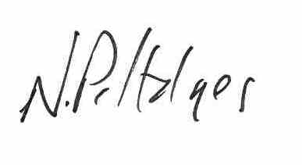
Yours sincerely,
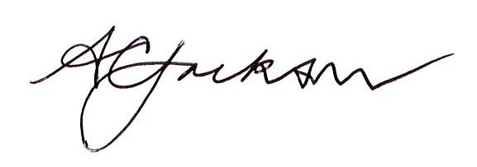

Mr Peter Hodges Mr A C Jackson
Old Barnardians’ Club Headmaster & President of the
Representative Governor Old Barnardians’ Club

__________________________________________________________

To: The Accounts Office, Barnard Castle School, Newgate, Barnard Castle, County Durham, DL12 8UN

Having read the information about membership of the Old Barnardians’ Club, I do not wish to enrol my daughter/son at this time.

Pupil’s Name:

School Number:

House:

Year Group:

Parent’s Signature:

Date:

