BARNARD CASTLE SCHOOL | BARNARD CASTLE | COUNTY DURHAM DL12 8UN | UNITED KINGDOM

BARNARD CASTLE SCHOOL

Commis Chef

INFORMATION FOR APPLICANTS

The History of Barnard Castle School

Barnard Castle School has its roots in the medieval past and its eyes set firmly on the future. The school traces its origins back to the nearby Hospital of St John, which was an educational and religious community established by John de Balliol in 1229. He was also the founder of Balliol College in Oxford and his passion for learning remains central to our philosophy today. In 1883 with a gift from Benjamin Flounders, a Victorian philanthropist, and the proceeds of St John’s Hospital, the present main School building was constructed. Tony Jackson, the School’s tenth Headmaster, was appointed in September 2017 as “Barney” embarked on an exciting new era.

The School

‘When you are steeped in little things, you shall safely attempt great things’

This motto perfectly sums up what Barnard Castle School - or ‘Barney’ as it is affectionately known - aims to do in preparing its pupils for life beyond its doors. Through creating an inspirational, compassionate and unpretentious environment, Barney aims to develop young adults with character. Our staff believe that our pupils should be confident, resilient, intellectually curious, tolerant and driven, with an undercurrent of humility, and are prepared to live, embrace and lead in an ever-changing world.

‘Parvis imbutus tentabis grandia tutus’

The School has a genuine warmth amongst its 722 pupils and 180 staff, which fosters a strong sense of community and endeavour. It is highly unusual to find a school where pupils from Year 9 and Year 11 sit at a table for lunch together sharing a conversation, discussing their latest sports fixture or drama rehearsal. However, this attitude is ingrained in a Barnardian from very early on. The co-educational and cross-year group atmosphere starts in the journey from the Preparatory School (ages 4-11) right through to the state-of-the-art bespoke Sixth Form Centre in the Senior School (ages 11-18). A Barney pupil is quick to make someone else feel at ease, whether that is through simple encouragement or a warm smile.

Whilst we are extremely proud of what our pupils achieve academically, we also recognise the importance of preparing the next generations for an evolving and increasingly competitive global marketplace. To do this, we focus on developing the individual character of every
child, and during their journey with us, we aim to cultivate vital life skills through building relationships amongst the pupil body and teachers alike. Each pupil has a dedicated Tutor who meets with them several times a week to discuss anything from pastoral issues to academic progress.
We want our pupils to develop a balanced mindset for life. This requires confidence, resilience and compassion, all built up over a period of time, and in a variety of ways, both within and beyond the classroom. It also requires that most important quality: humility. At our core is an unpretentious and humble outlook, and it is this combination of confidence and humility that allows our pupils to light up a room.
We want staff who believe in our purpose as educators and are proactive in immersing themselves in school life during term time. We would like them to role model the qualities we hope to install in our pupils throughout their journey from the Prep School through to the end of the Sixth Form. Teachers are expected to take part in the extensive extra-curricular “Mind, Body and Soul” programme that runs between 4pm and 5pm and can choose to offer an activity that they are passionate about. We believe in fostering lasting relationships and contact time with pupils outside the classroom is what makes the Barney difference.

BARNARD CASTLE SCHOOL | BARNARD CASTLE | COUNTY DURHAM DL12 8UN | UNITED KINGDOM

The School (cont’d)

The School is situated in its own extensive grounds on the outskirts of an historic market town, recently noted as being the safest in England, in an area of outstanding natural beauty. It is well-resourced and enjoys an enviable reputation for its pupils’ achievements on a broad variety of fronts. It is also in proximity to and enjoys close relationships with departments in the universities of Durham, York and Newcastle.
Continuous improvement and investment have produced a number of new buildings, including the MacFarlane Building which houses Physics and ICT, the Atha Fitness Centre, an extension to our Prep School including a new Science Lab, and the new purpose built Sixth Form Centre.
Further details about Barnard Castle School may be found in the Independent Schools’ Yearbook and on the School’s website www.barnardcastleschool.org.uk.

Our Vision
- To be viewed as the leading independent co-educational boarding and day school in the North of England.
- To foster the concept that ‘Barney is for Life’, imbuing a real sense that to be a Barnardian is something special and life-lasting.
- To make an impact: in Barnard Castle, County Durham and the wider world.
- To place the School in an even stronger position for future generations to enjoy all the benefits of a Barney education.

Our Purpose
- Through creating an inspirational, compassionate and unpretentious environment, we aim to develop young adults with character.
- They are happy, confident, resilient, intellectually curious, tolerant and driven, with an undercurrent of humility, who are ready and prepared to face, embrace and lead in an ever-changing world.

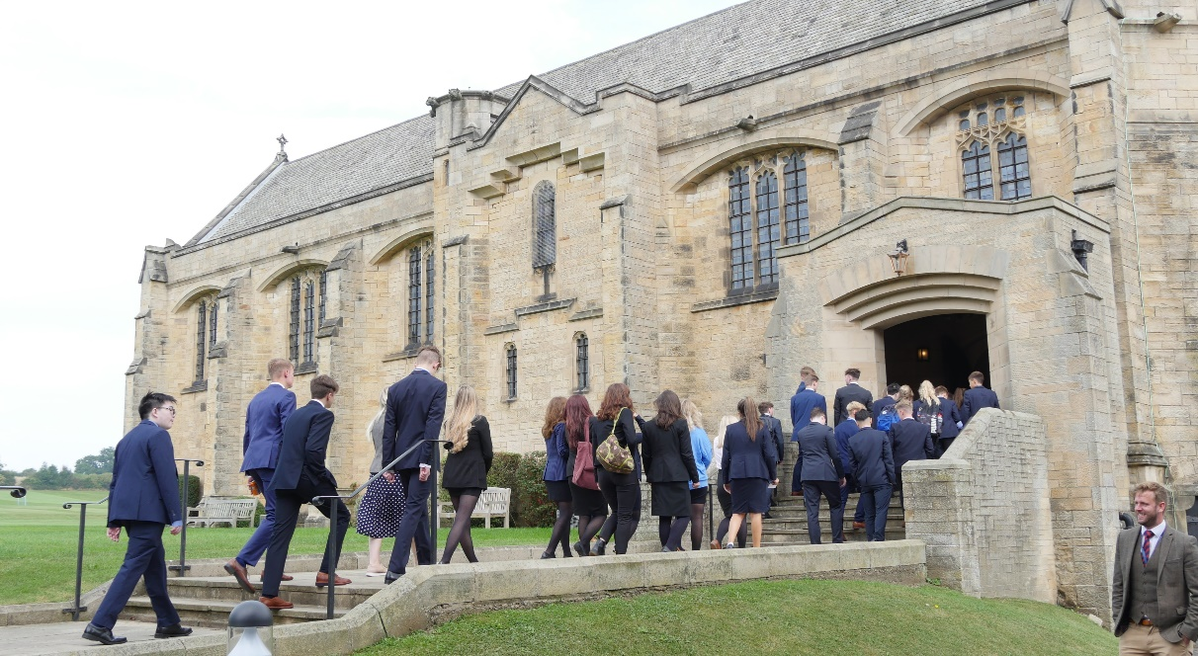

Job Description

Job Title: Commis Chef
Responsible to: Catering and Domestic Services Manager
Reporting to: Sous Chef
Department: Support-Catering

Purpose

The purpose of the role is to assist with the daily operation of the kitchen whilst ensuring the delivery of excellent food quality.

Overall Responsibilities:

General
- To take responsibility for the preparation, presentation and serving of all meals to an exceptional standard.
- Assist in catering for functions and events.
- Helping with deliveries and re-stocking

Specific
- To assist in the preparation and cooking of meals meals and buffets for pupils, staff and special functions as required by the Sous Chef and Executive Chef.
- To ensure routine day to day as well as specialised cleaning of kitchen equipment, work surfaces, kitchen floors and storage areas, as directed by the Executive Chef.
- To ensure waste is controlled with regard to preparation and cooking.
- To maintain the highest standards of health, hygiene and safety.
- To follow allergen and dietary procedures as required.
- Assisting with the management and control all food, to include; receiving and checking stock, checking equipment and materials are used correctly, closely monitoring portion control.
- To ensure that routine data is collected as required and that all daily checks, including temperature control during production, preparation, service and storage are carried out properly.
- To immediately report all accidents, near misses, damage or breakages to the Executive Chef.
- To actively assist in ensuring a five star food hygiene rating.
- To ensure that the Catering Department is opening and closed at the required times and secured when not in use.
- To undertake any other tasks appropriate with the duties and responsibilities of the post.
- To attend any relevant training sessions to ensure that you are fully equipped to perform your role effectively.
- To comply with any reasonable request from the Executive Chef and Sous Chef to undertake work of a similar level that is not specified in this job description.
- This job description is current at the time of issue but may be changed by management to reflect changes in the role, which are commensurate with the salary and job title.

In order to meet the high standards expected of a member of staff in our School, the Bursar is seeking to employ a person with the following qualities, experience, skills and abilities.

Person Specification

Essential Requirements

- Ability to carry out all aspects of the role to a high standard at all times.
- Excellent social and verbal communication skills.
- Positive attitude.
- Approachable and flexible.
- A common sense approach.
- Must be able to work on own initiative, and with resilience.
- The ability to organise workload and multi-task.
- The ability to work without direct supervision.
- The ability to work as a member of a team.
- Excellent attendance and punctuality.
- Highly motivated with a drive to introduce continuous improvement.
- Reliable.
- Experience of delivering a professional catering service.

Desirable Requirements

- NVQ Level 1 or 2 Catering & Hospitality.
- Certificate in food hygiene and training.
- Certificate in First Aid.
- Certificate in Health & Safety including knowledge of COSHH regulations, safe storage and working practices.
- Experience of delivering a catering service in a high volume environment.
- Experience of working in a boarding school or residential environment.
- Awareness of child protection and safeguarding procedures/The Children’s Act.

Minimum Training :-

The following training courses are considered to be a minimum requirement for the post and will be planned as appropriate to support the role, responsibilities and duties undertaken:-
- Health and Safety
- Fire Safety Awareness
- Food Hygiene
- Child Protection and Safeguarding
- Allergens

Expectations as a member of Barnard Castle School Staff

- To have high professional standards and so be an appropriate role model of reliability, behaviour and appearance
- To relate to children in an atmosphere of trust, frankness and ambition and to engender a climate of mutual respect
- To make sure that pupils meet the School’s expectations of them
- To facilitate the development of children’s confidence, self-esteem, determination, responsibility and personal pride in achievement, behaviour and appearance
- To understand that offering a well-rounded education means engaging beyond the classroom, and therefore contributing to the wider life of the Barney education.

- To contribute to marketing the school and to promote the School to prospective pupils and parents
- To establish and maintain high standards of communication with pupils, staff and parents
- To uphold all the policies of Barnard Castle School
- To take an interest in how the School functions and to convey suggestions for improvement to the Domestic Services and Catering Manager, Senior Management Team and Headmaster from time to time
- To subscribe to the School’s ethos of inclusivity, collegiality and helpfulness.

This job description reflects the present requirements of the post and is not intended to be exhaustive. staff may be required to carry out such other duties as the Bursar may reasonably require from time to time.

Duties and responsibilities, may be subject to change and development, the job description will be reviewed periodically and subject to amendment in consultation with the post holder.

Support

The staff member will be appraised by their Line Manager but routine communication will be on going and professional development.

Appointment Terms, Conditions and Benefits

Type: Permanent contract

Probationary Period: 6 months

Working Hours: 40 hours per week

Hourly rate: Up to £12.00 dependent upon experience

Notice: During the probationary period by School and Employee is one week in writing. Post probationary is 1 month.

Absence: Entitlement to Statutory Sick pay (SSP) only during the first two years. School sick pay as detailed in contract will apply in later years.

Paid holidays:

20 days annual leave per annum plus bank holidays.
The annual leave year runs 1st September to 31st August. Holidays should be taken during School holidays.
As we are a Boarding School, some public holidays (usually May Day) are a normal working day and a lieu day can be taken in School holiday working weeks for this

Pension: In accordance with current pension legislation, Support Staff are automatically enrolled in The Pensions Trust Flexible Retirement Plan scheme unless they choose to opt out. More information is available on request.

Recruitment Process

Barney Application Process:

If you feel that you can meet the above requirements, then please submit a letter of application along with the Barnard Castle School application form to the Bursar. Only applications containing the requested information will be considered.

Applications should be sent to:
Mrs S M Metcalf
Bursar
Barnard Castle School County Durham
DL12 8UN

Phone 01833 696098

Fax 01833 638985

E-mail hr@barneyschool.org.uk

Interviews
Interviews will take place at Barnard Castle School
Closing Date :
Applications will be considered as they arrive

Information about Interviews:

Applicants should read carefully the application procedure – guidance for applicants, Policy on the Recruitment of Ex-offenders and the Disclosure policy and the Safer Recruitment policy.
Barnard Castle School is committed to safeguarding and promoting the welfare of children and young people and expects all staff and volunteers to share this commitment. This post is exempt from the Rehabilitation of Offenders Act 1974 and all applicants will undergo child protection screening, including checks with past employers and an enhanced DBS and Barred list check with Disclosure and Barring Service.
Barnard Castle School is an equal opportunities employer.

WWW. B ARNARDCASTLESCHOOL.ORG .UK

