 |  |  | Week 3 Lunch Menu
Monday | Tuesday | Wednesday | Thursday | Friday | Saturday | Sunday
Homemade Thai Vegetable Soup | Homemade Mexican Bean Soup | Homemade Sweet Potato and Coconut Soup | Homemade Roasted Tomato Soup | Homemade Mushroom and Tarragon Soup
Main Course | Main Course | Main Course | Main Course | Main Course | Main Course
Cottage Pie Topped with Herb Mash | Chicken | Roasted Pork, Apple Sauce and Gravy | Beef Bourguignonne | Beer Battered Fish and Chips Tartare Sauce and Lemon | Pasta Bar with a Selection of Sauces and Sides | Barney Brunch
Vegetarian  Potato Onion and Cheese Pasty | Vegetarian  Vegetarian Sausages | Vegetarian  Root Vegetable Crumble | Vegetarian  Moroccan Chickpea and vegetable Tagine & Cous Cous | Vegetarian  Olive, Feta and Tomato Tart
Sides | Sides | Sides | Sides | Sides
New Potatoes  Garden Peas  Roasted Carrot | Mash Potatoes  Root Vegetables  Broccoli | Roasted Potatoes  Carrots  Cabbage | Turmeric Rice  Green Beans  Honeyed Crushed Swede | Chips  Mushy Peas  Baked Beans  Curry Sauce
Pasta Bar | Jacket Bar | Pasta Bar | Jacket Bar | Pasta Bar
Vegetable Ragu | Baked Beans  Tuna Mayo  Grated Cheese | Arribiatta Sauce | Baked Beans  Grated Cheese  Spiced Chicken | Tomato and Basil
Dessert of the Day | Dessert of the Day | Dessert of the Day | Dessert of the Day | Dessert of the Day | Dessert of the Day | Dessert of the Day
Chocolate Puddle Pudding | Fruit Crumble and Custard | Baked Rice Pudding and Jam | Jelly and Fresh Fruit | Chocolate Brownie | Doughnuts with Toffee Sauce | Cherry Shortbread and Custard
Fruit And Yogurt Bar | Fruit And Yogurt Bar | Fruit And Yogurt Bar | Fruit And Yogurt Bar | Fruit And Yogurt Bar | Fruit And Yogurt Bar | Fruit And Yogurt Bar
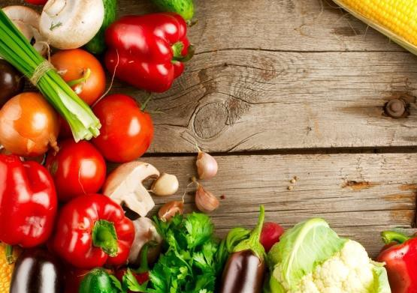
Salad Bar served daily

If you require allergen information for any of our dishes, please speak to a member of staff and we will be more than happy to help.

