 |  |  | Week 2 Lunch Menu
Monday | Tuesday | Wednesday | Thursday | Friday | Saturday | Sunday
Homemade Tomato Soup | Homemade Spicy Bean Soup | Homemade Carrot and Coriander Soup | Homemade Mulligatawny Soup | Homemade Pea and Mint Soup
Main Course | Main Course | Main Course | Main Course | Main Course | Main Course | Main Course
Tray bake Chicken Thighs | Grilled Pork & Apple Sausages | Roasted Turkey with Sage Onion Stuffing and Gravy | Chicken Korma & Naan Breads | Fish and Chips Tartare Sauce and Lemon | Pasta Bar | Barney Brunch
Vegetarian  Butterbean Stew Cheese and Herb Dumplings | Vegetarian  Vegetarian Sausages | Vegetarian  Vegetable and Lentil Hotpot | Vegetarian  Chickpea, sweet potato Balti & Naan Breads | Vegetarian  Quorn Chili and Rice
Sides | Sides | Sides | Sides | Sides
Roasted New Potatoes  Green Beans  Steamed Carrot | Mash Potatoes  Root Vegetables  Broccoli | Roasted Potatoes  Cauliflower Cheese  Mixed Vegetables | Turmeric Rice  Coconut Green Beans  Poppadom | Chips  Garden Peas  Baked Beans  Curry Sauce
Pasta Bar | Jacket Bar | Pasta Bar | Jacket Bar | Pasta Bar
Red Pepper and Basil | Baked Beans  Tuna Mayo  Grated Cheese | Arribiatta Sauce | Baked Beans  Grated Cheese  Spiced Chicken | Tomato and Basil
Dessert of the Day | Dessert of the Day | Dessert of the Day | Dessert of the Day | Dessert of the Day | Dessert of the Day | Dessert of the Day
Baked Lemon Sponge Orange Sauce | Fruit Crumble and Custard | Banana and Chocolate Chip Cake | Vanilla Cheesecake | Rocky Road | Doughnuts with Toffee Sauce
Fruit And Yogurt Bar | Fruit And Yogurt Bar | Fruit And Yogurt Bar | Fruit And Yogurt Bar | Fruit And Yogurt Bar | Fruit And Yogurt Bar | Fruit And Yogurt Bar
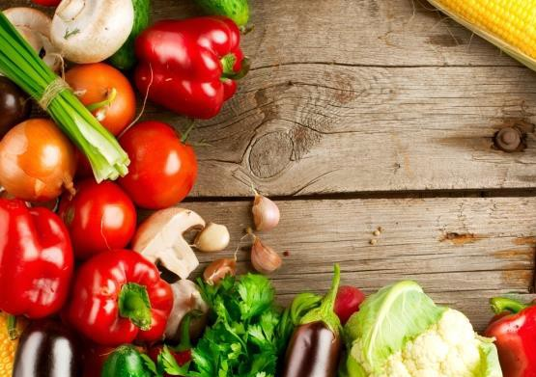
Salad Bar served daily

If you require allergen information for any of our dishes, please speak to a member of staff and we will be more than happy to help.

