Week 1
Lunch Menu
Monday | Tuesday | Wednesday | Thursday | Friday | Saturday | Sunday
Homemade Tomato & Basil Soup | Homemade Leek and Potato Soup | Homemade Carrot and Coriander Soup | Homemade Garden Vegetable Soup | Homemade Curried Parsnip Soup
Main Course | Main Course | Main Course | Main Course | Main Course | Main Course | Main Course
Chilli Con Carne  Tortilla Chips | Pork Strips in Soy with Mushrooms & Bean Shoots | Roast Beef Gravy and Yorkshire Pudding | Baked Chicken Leg, Apricot Glaze & Paprika Mayo | Battered Catch of the Day with Tartare Sauce and Lemon | Local Bangers and Mash | Deli Bar
Vegetarian  Bean & Vegetable Chilli | Vegetarian  Tofu and Mushroom Katsu Curry | Vegetarian  Roasted Pepper & Mozzarella Tartlets | Vegetarian  Tomato and Garlic Sausage, Red Onion Salsa | Vegetarian  Cheese and Onion Pasties | Vegetarian  Vegetable Bangers and Mash | Vegetarian
Sides | Sides | Sides | Sides | Sides | Sides | Sides
Potato Wedges  Soured Cream  Green Beans Salsa Carrot | Egg Fried Rice  Prawn Crackers  Sesame Broccoli | Herbed New Potatoes  Cauliflower Cheese Savoy Cabbage | Tomato Rice  Crispy Kale  Cajun and Lime Corn Cob | Skinny Chips  Garden Peas  Baked Beans  Curry Sauce | Roasted Roots  Gravy
Pasta Bar | Jacket Bar | Pasta Bar | Jacket Bar | Pasta Bar
Tomato & Basil | Baked Beans  Tuna Mayo  Grated Cheese | Pesto Cream | Baked Beans  Grated Cheese  Spiced Chicken | Tomato and Basil
Dessert of the Day | Dessert of the Day | Dessert of the Day | Dessert of the Day | Dessert of the Day | Dessert of the Day | Dessert of the Day
Vanilla Sponge & Custard | Marble Cake | Lemon Drizzle | Yoghurt Cake | Chocolate Sponge with Custard | Steamed Syrup Pudding | Pineapple Upside Cake and Cream
Fruit And Yogurt Bar | Fruit And Yogurt Bar | Fruit And Yogurt Bar | Fruit And Yogurt Bar | Fruit And Yogurt Bar | Fruit And Yogurt Bar | Fruit And Yogurt Bar
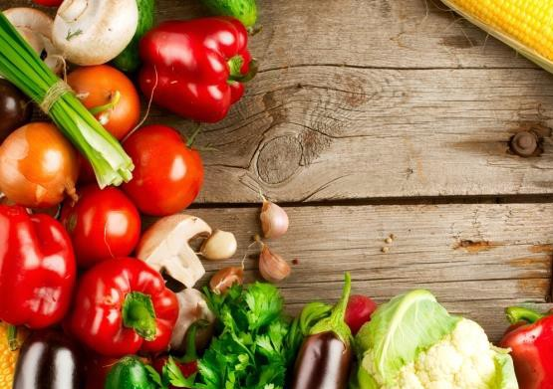
Salad Bar served daily

If you require allergen information for any of our dishes, please speak to a member of staff and we will be more than happy to help.

