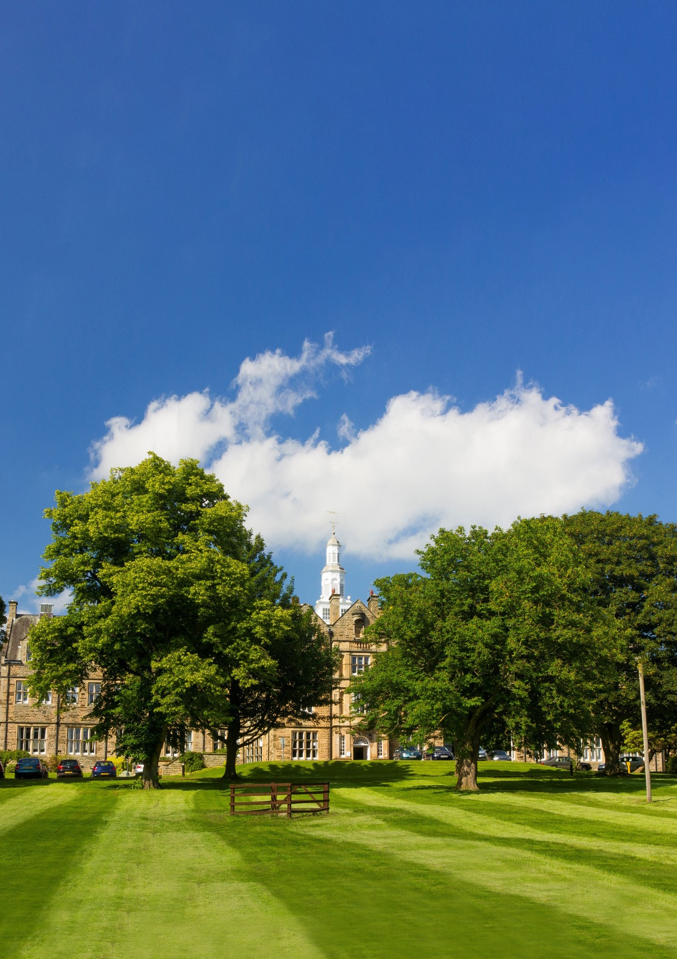
BARNARD CASTLE SCHOOL | BARNARD CASTLE | COUNTY DURHAM DL12 8UN | UNITED KINGDOM

BARNARD CASTLE SCHOOL

Teacher of Music

INFORMATION FOR APPLICANTS

The History of Barnard Castle School

Barnard Castle School has its roots in the medieval past and its eyes set firmly on the future. The school traces its origins back to the nearby Hospital of St John, which was an educational and religious community established by John de Balliol in 1229. He was also the founder of Balliol College in Oxford and his passion for learning remains central to our philosophy today. In 1883 with a gift from Benjamin Flounders, a Victorian philanthropist, and the proceeds of St John’s Hospital, the present main School building was constructed. Tony Jackson, the School’s tenth Headmaster, was appointed in September 2017 as “Barney” embarked on an exciting new era.

The School

‘When you are steeped in little things, you shall safely attempt great things’

This motto perfectly sums up what Barnard Castle School - or ‘Barney’ as it is affectionately known - aims to do in preparing its pupils for life beyond its doors. Through creating an inspirational, compassionate and unpretentious environment, Barney aims to develop young adults with character. Our staff believe that our pupils should be confident, resilient, intellectually curious, tolerant and driven, with an undercurrent of humility, and are prepared to live, embrace and lead in an ever-changing world.

‘Parvis imbutus tentabis grandia tutus’

The School has a genuine warmth amongst its 722 pupils and 180 staff, which fosters a strong sense of community and endeavour. It is highly unusual to find a school where pupils from Year 9 and Year 11 sit at a table for lunch together sharing a conversation, discussing their latest sports fixture or drama rehearsal. However, this attitude is ingrained in a Barnardian from very early on. The co-educational and cross-year group atmosphere starts in the journey from the Preparatory School (ages 4-11) right through to the state-of-the-art bespoke Sixth Form Centre in the Senior School (ages 11-18). A Barney pupil is quick to make someone else feel at ease, whether that is through simple encouragement or a warm smile.

Whilst we are extremely proud of what our pupils achieve academically, we also recognise the importance of preparing the next generations for an evolving and increasingly competitive global marketplace. To do this, we focus on developing the individual character of every
child, and during their journey with us, we aim to cultivate vital life skills through building relationships amongst the pupil body and teachers alike. Each pupil has a dedicated Tutor who meets with them several times a week to discuss anything from pastoral issues to academic progress.
We want our pupils to develop a balanced mindset for life. This requires confidence, resilience and compassion, all built up over a period of time, and in a variety of ways, both within and beyond the classroom. It also requires that most important quality: humility. At our core is an unpretentious and humble outlook, and it is this combination of confidence and humility that allows our pupils to light up a room.
We want staff who believe in our purpose as educators and are proactive in immersing themselves in school life during term time. We would like them to role model the qualities we hope to install in our pupils throughout their journey from the Prep School through to the end of the Sixth Form. Teachers are expected to take part in the extensive extra-curricular “Mind, Body and Soul” programme that runs between 4pm and 5pm and can choose to offer an activity that they are passionate about. We believe in fostering lasting relationships and contact time with pupils outside the classroom is what makes the Barney difference.

BARNARD CASTLE SCHOOL | BARNARD CASTLE | COUNTY DURHAM DL12 8UN | UNITED KINGDOM

The School (cont’d)

The School is situated in its own extensive grounds on the outskirts of an historic market town, recently noted as being the safest in England, in an area of outstanding natural beauty. It is well-resourced and enjoys an enviable reputation for its pupils’ achievements on a broad variety of fronts. It is also in proximity to and enjoys close relationships with departments in the universities of Durham, York and Newcastle.
Continuous improvement and investment have produced a number of new buildings, including the MacFarlane Building which houses Physics and ICT, the Atha Fitness Centre, an extension to our Prep School including a new Science Lab, and the new purpose built Sixth Form Centre.
Further details about Barnard Castle School may be found in the Independent Schools’ Yearbook and on the School’s website www.barnardcastleschool.org.uk.

Our Vision
- To be viewed as the leading independent co-educational boarding and day School in the North of England.
- To foster the concept that ‘Barney is for Life’, imbuing a real sense that to be a Barnardian is something special and life-lasting.
- To make an impact: in Barnard Castle, County Durham and the wider world.
- To place the School in an even stronger position for future generations to enjoy all the benefits of a Barney education.

Our Purpose
- Through creating an inspirational, compassionate and unpretentious environment, we aim to develop young adults with character.
- They are happy, confident, resilient, intellectually curious, tolerant and driven, with an undercurrent of humility, who are ready and prepared to face, embrace and lead in an ever-changing world.

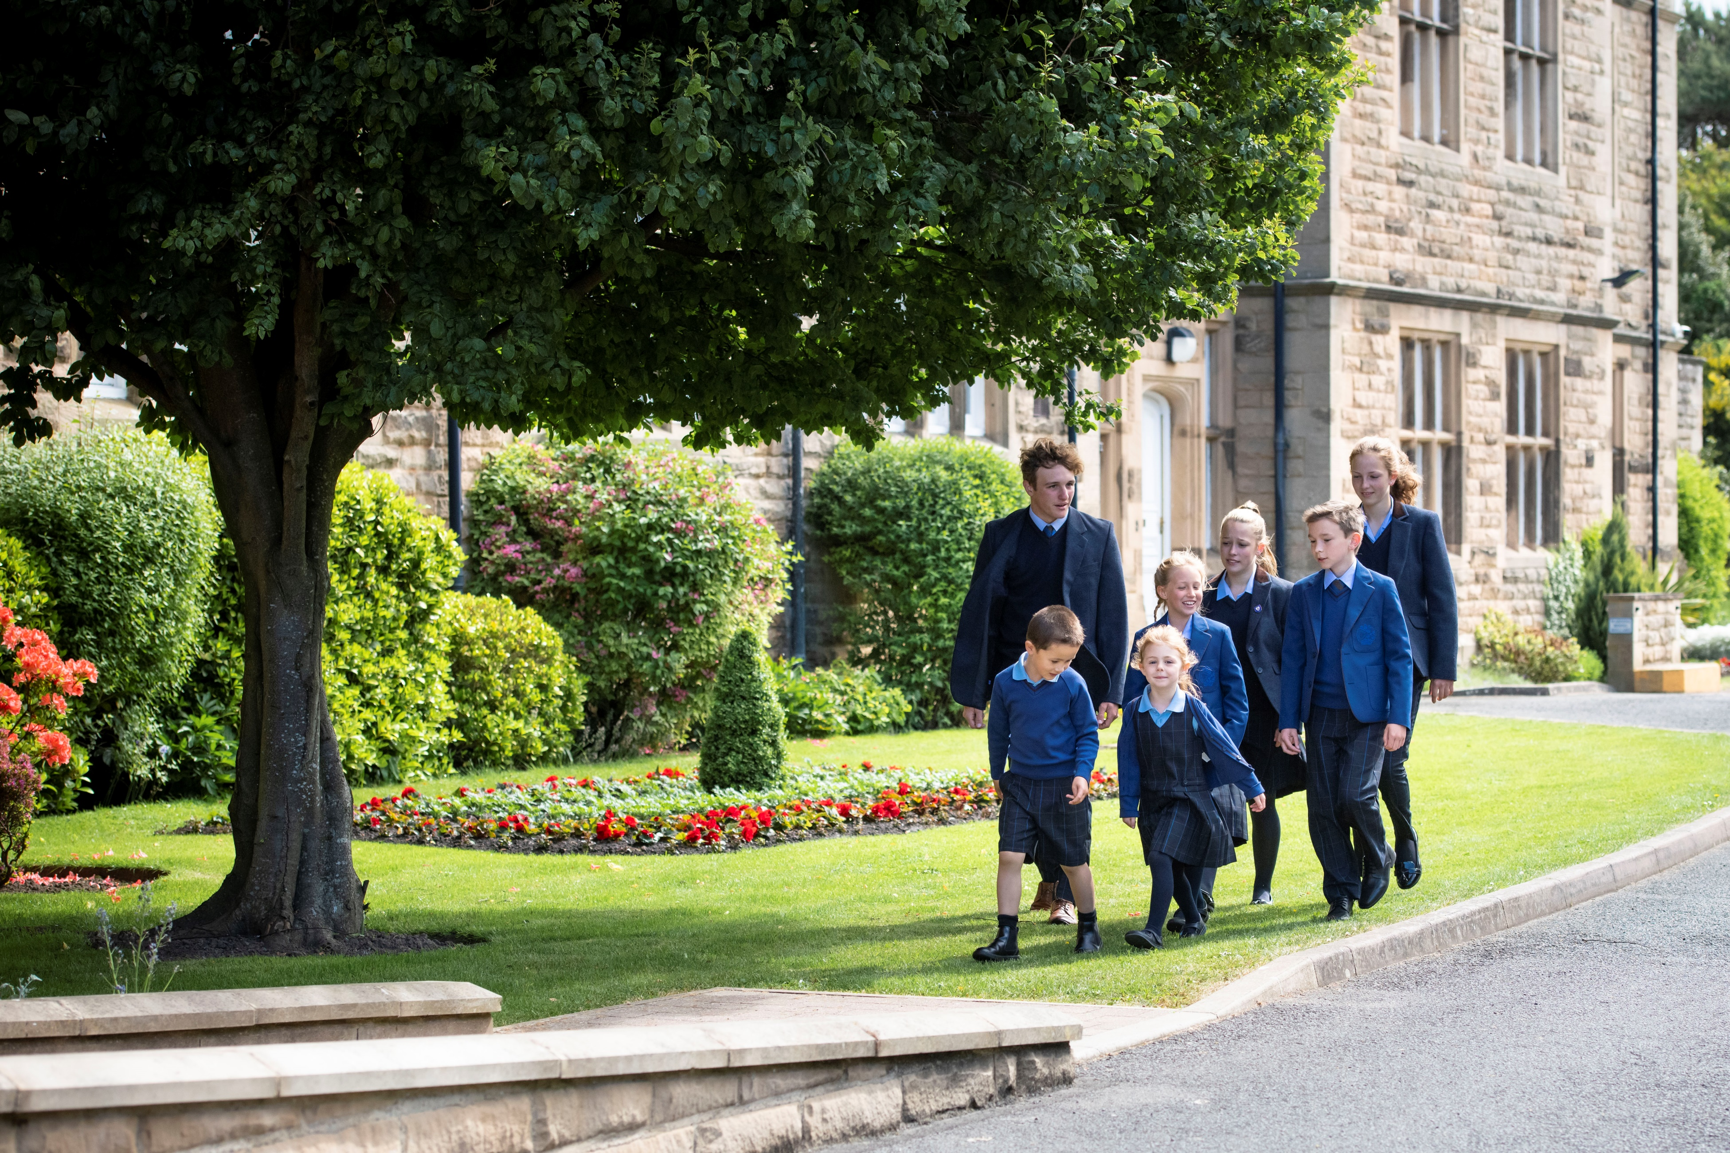

BARNARD CASTLE SCHOOL | BARNARD CASTLE | COUNTY DURHAM DL12 8UN | UNITED KINGDOM

Job Description

Job Title:
TEACHER OF MUSIC
Reporting to:
DIRECTOR OF MUSIC

Brief
Barney has a busy and thriving Music Department, offering a range of outstanding opportunities to the pupils that study here. The Department aims to foster a love of music in every pupil with the intention of encouraging a culture of aspiration and high standards alongside enjoyment for music. At the heart of the department is the firm belief that every child is a musician.

The department is currently staffed by five full-time members of staff: The Director of Music, The Bandmaster & Head of Woodwind, a Teacher of Music, a Graduate Teacher of Music and a Gap Year Musician. There are also 17 Visiting Music Teachers who teach around 250 individual lessons each week. Many pupils in the school learn at least one musical instrument, and this is aided by schemes that offer free or subsidised instrumental lessons in particular
instruments.

Facilities for Music include a Recital Room, two class teaching rooms, 5 practice rooms and a Music Library. Large-scale concerts take place in Big School (the main school hall), which has recently been refurbished, and the School Chapel, which contains a fine, two-manual Fr Willis organ. As a result of our location, Barney is also able to hold performances in outstanding local venues such as the Bowes Museum and The Witham in Barnard Castle. Plans are underway for the development of a new Performing Arts Centre.

The Music Department has a superb relationship with the Drama Department. The two departments regularly join together to go on school trips, and recent musicals performed in school include Oliver!, Made in Dagenham; One Man, Two Guvnors and Seussical.

Academic Music
All pupils in Years 7-9 study music for either one or two lessons per week as part of Barney’s core curriculum. Music is a popular subject at GCSE, where pupils study the Eduqas course. A number of pupils also go on to study Music at A Level (Eduqas) and degree level. There is also a strong tradition of pupils taking up choral and organ scholarships at Oxbridge and other universities and conservatoires.

Co-Curricular Music
Music is a hugely important part of life at Barney, and pupils are encouraged to participate in a range of co-curricular activities each week.

Alongside individual music lessons, there are also a range of ensembles for pupils of all levels to take part in. Usually, these include Prep School Orchestra, Junior Orchestra, Senior Orchestra, Wind Band, Jazz Band and Rock and Pop Bands, as well as a number of smaller ensembles, which include Sax Ensemble, Senior Wind Ensemble, Junior Wind Ensemble, Brass Ensemble, and Chamber Ensembles.

There is a strong history of choral singing at Barney. The 60-strong Chapel Choir sing for services both in and out of school, and have recently sung at Durham Cathedral, Newcastle Cathedral, Hexham Abbey and St Paul’s Cathedral. The smaller, auditioned Chamber Choir learn more secular repertoire and perform regularly in concerts. The recently formed Prep School Chamber Choir has attracted 36 pupils in its first term. There is also the 70-strong school Choral Society made up of pupils, parents, staff and members of the local community.

Pupils are offered regular opportunities to perform both as soloists and as part of ensembles. Each term ends with at least one large-scale concert, and there are many other smaller concerts throughout the year. These include the popular Friday Lunchtime Concerts in the Music School, Music Scholars’ and Diploma Concerts and Showcase Concerts at The Witham. There are also masterclasses, workshops and concerts given by high-profile external musicians. Recently, the Chapel Choir were able to work with the Gesualdo Six prior to singing for the four Festival of Nine Lessons and Carols services, and the group gave an evening concert in the School Chapel. In March 2022, the whole school will travel to the Sage Gateshead for a concert in which every pupil will take part.

Music Scholarships
Each year, Music Scholarships are awarded to pupils at 11+, 13+ and 16+ entry. These young musicians are ambassadors for music in the school, and hold important roles within the life of the Music Department. As part of the Music Scholarship, pupils receive individual support and guidance, and are able to attend a range of trips free of charge. They also receive free instrumental tuition in their principal instrument. There is also a Young Organist Scheme, which each year offers free organ lessons to pupils in the Senior School that wish to begin learning the instrument. There are currently eight pupils learning under this scheme.

To see what our busy department gets up to on a day-to-day basis, please visit the Music
Department Twitter account: www.twitter.com/music_barney

BARNARD CASTLE SCHOOL | BARNARD CASTLE | COUNTY DURHAM DL12 8UN | UNITED KINGDOM

Barnard Castle School is looking to appoint an energetic, enthusiastic and inspiring Teacher of Music to join our Music Department in September 2022. The successful candidate will be expected to teach in both the Prep and Senior Schools and contribute fully to department life. This is a full-time role.

At the heart of the music department is the firm belief that every child is a musician, and we aim to cultivate a culture in which all pupils enjoy making music on a weekly basis. Every single pupil in the school takes part in weekly singing sessions, and a high proportion of pupils learn one or more instruments. There is a broad range of instrumental and choral ensembles for pupils to take part in, and music is taught at both GCSE and A Level.

The successful applicant will be enthusiastic, well-organised, and keen to motivate and inspire young musicians of all abilities. They will have consistently high expectations of themselves and their pupils, and should demonstrate excellent classroom management and pastoral skills. The ability to play the organ and piano to a high standard alongside strong sight-reading skills would be particularly welcome, but candidates with a high level of playing in non-keyboard instruments are still encouraged to apply. The post would be equally suitable for someone seeking a first appointment or an experienced teacher.

Barnard Castle School has its own salary scale, as well as a generous Pension Scheme and a reduction in school fees. There is also the possibility of on-site accommodation available for single occupancy.

The closing date for applications is 9am on Monday 7th February 2022. Interviews will be held during the week commencing Monday 21st February 2022.

School and Department values and ethos
- To work as part of a team, in harmony with and for the furtherance of the school’s ethos and declared educational aims and priorities;
- To assist the Director of Music in the delivery of the Departmental Plan for music,
- helping to cultivate a happy and ambitious department in which every child is a musician;
- Oversee a tutor group in the Senior School.

Curriculum
- To teach an exciting, diverse and relevant curriculum to pupils in the Prep and Senior Schools;
- To be aware of the need to differentiate work and challenges according to the ability of the pupils, whilst maintaining high expectations of all and taking full account of any
- Special Educational Needs;
- Contribute to the preparation and writing of Schemes of Work, teaching materials, teaching programmes, methods of teaching and assessment;
- To provide pupils with regular feedback and encourage them to reflect and respond to this feedback;
- To provide parents with written reports on their students’ work and progress according to current school policy and to attend parents’ meetings;
- To report in a timely manner any concerns about students and their learning progress to the appropriate colleague.
Extra-Curricular
- To participate fully in the wider life of the Music Department, and provide inspirational musical opportunities to pupils of all ages and abilities;
- To rehearse and direct ensembles in both the Prep and Senior Schools;
- To support and take part in ensembles as requested by the Director of Music;
- To contribute to Barnard Castle School’s broad and active co-curricular activities programme.

Other Responsibilities
- To assist in the day-to-day running of a busy music department;
- Assisting with general administrative tasks;
- Accompany for concerts and rehearsals (if a keyboard player);
- Accompany the Chapel Choir and play for Chapel Services (if an organist);
- To take responsibility for one’s continuing professional development and, to this end, to participate in Development and Review procedures as directed by the Headmaster;
- To take a share of supervising duties, invigilation and cover for absent colleagues;
- To be responsible for the supervision, control and proper use of teaching rooms, materials and resources, and to have regard to health and safety issues and regulations;
- To attend weekly staff meetings and other meetings that may be called from time to time, as required by the Headmaster;
- Undertake any other reasonable tasks required by the Headmaster and/or Director of Music in association with this role.
Expectations as a member of Barnard Castle School Common Room
- To have high professional standards and so be an appropriate role model of reliability, behaviour and appearance
- To relate to children in an atmosphere of trust, frankness and ambition and to engender a climate of mutual respect
- To make sure that pupils meet the School’s expectations of them
- To facilitate the development of children’s confidence, self-esteem, determination, responsibility and personal pride in achievement, behaviour and appearance
- To understand that offering a well-rounded education means engaging beyond the classroom, and therefore contributing to the wider life of the Barney education.
- To contribute to marketing the school and to promote the School to prospective pupils and parents
- To establish and maintain high standards of communication with pupils, staff and parents
- To uphold all the policies of Barnard Castle School
- To take an interest in how the School functions and to convey suggestions for improvement to the Head of Department, Senior Management Team and Headmaster from time to time;
- To subscribe to the Common Room’s ethos of inclusivity, collegiality and helpfulness.

BARNARD CASTLE SCHOOL | BARNARD CASTLE | COUNTY DURHAM DL12 8UN | UNITED KINGDOM

Essential Criteria:

- A good honours degree in Music or equivalent;
- Commitment to the safeguarding and welfare of all pupils;
- Experience of delivering outstanding lessons to pupils of varying ages and abilities;
- Experience of supporting pupils of varying ages and abilities to make excellent progress;
- Experience of directing/conducting ensembles;
- A proven track record as a highly capable instrumentalist;
- Ability to communicate a passion for Music to young people;
- Professional appearance and demeanour;
- Enthusiastic about working in a school environment and with young people;
- Excellent written and verbal communication skills;
- Excellent organisational skills and the ability to meet deadlines;
- Good IT Literacy;
- Team-player and enthusiastic about music-making at the school.

Desirable Criteria:
- A record of and commitment to continuing professional development;
- Possession of QTS;
- Strong keyboard skills/experience as an organist and pianist;
- A willingness to contribute to boarding: single-person accommodation may be available for those who undertake boarding duties;
- The ability to develop and maintain effective relationships with all members of the school community;
- Sympathy with the Christian values of the School and the nature of working in a boarding environment.

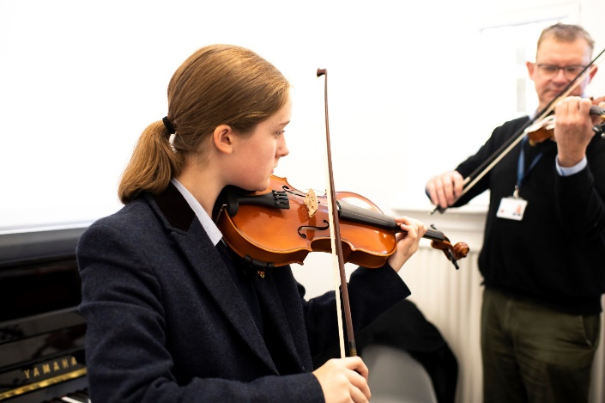
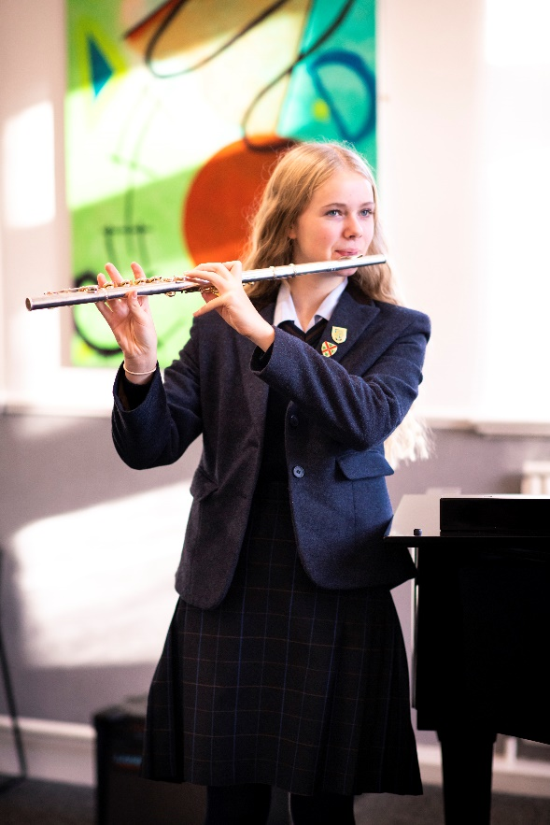

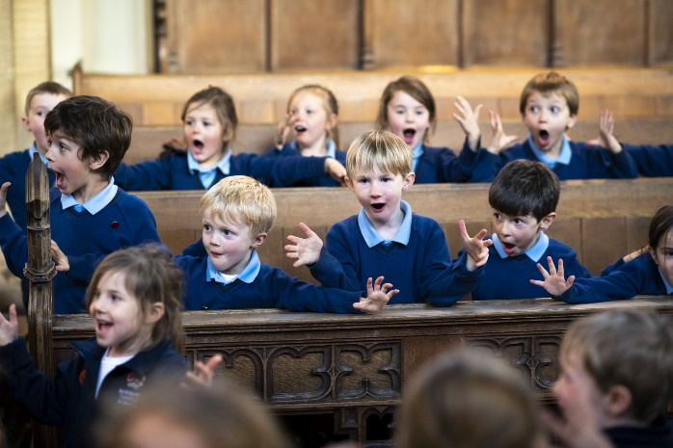

BARNARD CASTLE SCHOOL | BARNARD CASTLE | COUNTY DURHAM DL12 8UN | UNITED KINGDOM

Recruitment Process
Barney Application Process:

If you feel that you can meet the above requirements then please submit a letter of application along with the Barnard Castle School application form to the Headmaster. Only applications containing the requested information will be considered.

Applications should be sent to:
Mr A C Jackson Phone 01833 696098
Headmaster Fax 01833 638985
Barnard Castle School E-mail hr@barneyschool.org.uk
County Durham
DL12 8UN

Closing Date Interviews
Wednesday 9th February 2022 at 9.00am Week commencing Monday 21st February 2022

Information about Interviews:

Applicants should read carefully the application procedure – guidance for applicants, Policy on the Recruitment of Ex-offenders and the Disclosure policy and the Safer Recruitment policy.
Barnard Castle School is committed to safeguarding and promoting the welfare of children and young people and expects all staff and volunteers to share this commitment. This post is exempt from the Rehabilitation of Offenders Act 1974 and all applicants will undergo child protection screening, including checks with past employers and an enhanced DBS and Barred list check with Disclosure and Barring Service.
Barnard Castle School is an equal opportunities employer.

WWW. B ARNARDCASTLESCHOOL.ORG .UK

