BARNARD CASTLE SCHOOL | BARNARD CASTLE | COUNTY DURHAM DL12 8UN | UNITED KINGDOM

BARNARD CASTLE SCHOOL

SENCO – Academic Learning Support

(Whole School)

INFORMATION FOR APPLICANTS

The History of Barnard Castle School

Barnard Castle School has its roots in the medieval past and its eyes set firmly on the future. The school traces its origins back to the nearby Hospital of St John, which was an educational and religious community established by John de Balliol in 1229. He was also the founder of Balliol College in Oxford and his passion for learning remains central to our philosophy today. In 1883 with a gift from Benjamin Flounders, a Victorian philanthropist, and the proceeds of St John’s Hospital, the present main School building was constructed. Tony Jackson, the School’s tenth Headmaster, was appointed in September 2017 as “Barney” embarked on an exciting new era.

The School

‘When you are steeped in little things, you shall safely attempt great things’

This motto perfectly sums up what Barnard Castle School - or ‘Barney’ as it is affectionately known - aims to do in preparing its pupils for life beyond its doors. Through creating an inspirational, compassionate and unpretentious environment, Barney aims to develop young adults with character. Our staff believe that our pupils should be confident, resilient, intellectually curious, tolerant and driven, with an undercurrent of humility, and are prepared to live, embrace and lead in an ever-changing world.

‘Parvis imbutus tentabis grandia tutus’

The School has a genuine warmth amongst its 722 pupils and 180 staff, which fosters a strong sense of community and endeavour. It is highly unusual to find a school where pupils from Year 9 and Year 11 sit at a table for lunch together sharing a conversation, discussing their latest sports fixture or drama rehearsal. However, this attitude is ingrained in a Barnardian from very early on. The co-educational and cross-year group atmosphere starts in the journey from the Preparatory School (ages 4-11) right through to the state-of-the-art bespoke Sixth Form Centre in the Senior School (ages 11-18). A Barney pupil is quick to make someone else feel at ease, whether that is through simple encouragement or a warm smile.

Whilst we are extremely proud of what our pupils achieve academically, we also recognise the importance of preparing the next generations for an evolving and increasingly competitive global marketplace. To do this, we focus on developing the individual character of every child, and during their journey with us, we aim to cultivate vital life skills through building relationships amongst the pupil body and teachers alike. Each pupil has a dedicated Tutor who meets with them several times a week to discuss anything from pastoral issues to academic progress.

We want our pupils to develop a balanced mindset for life. This requires confidence, resilience and compassion, all built up over a period of time, and in a variety of ways, both within and beyond the classroom. It also requires that most important quality: humility. At our core is an unpretentious and humble outlook, and it is this combination of confidence and humility that allows our pupils to light up a room.

We want staff who believe in our purpose as educators and are proactive in immersing themselves in school life during term time. We would like them to role model the qualities we hope to install in our pupils throughout their journey from the Prep School through to the end of the Sixth Form. Teachers are expected to take part in the extensive extra-curricular “Mind, Body and Soul” programme that runs between 4pm and 5pm and can choose to offer an activity that they are passionate about. We believe in fostering lasting relationships and contact time with pupils outside the classroom is what makes the Barney difference.

BARNARD CASTLE SCHOOL | BARNARD CASTLE | COUNTY DURHAM DL12 8UN | UNITED KINGDOM

The School (cont’d)

The School is situated in its own extensive grounds on the outskirts of an historic market town, recently noted as being the safest in England, in an area of outstanding natural beauty. It is well-resourced and enjoys an enviable reputation for its pupils’ achievements on a broad variety of fronts. It is also in proximity to and enjoys close relationships with departments in the universities of Durham, York and Newcastle.
Continuous improvement and investment have produced a number of new buildings, including the MacFarlane Building which houses Physics and ICT, the Atha Fitness Centre, an extension to our Prep School including a new Science Lab, and the new purpose built Sixth Form Centre.
Further details about Barnard Castle School may be found in the Independent Schools’ Yearbook and on the School’s website www.barnardcastleschool.org.uk.

Our Vision
- To be viewed as the leading independent co-educational boarding and day School in the North of England.
- To foster the concept that ‘Barney is for Life’, imbuing a real sense that to be a Barnardian is something special and life-lasting.
- To make an impact: in Barnard Castle, County Durham and the wider world.
- To place the School in an even stronger position for future generations to enjoy all the benefits of a Barney education.

Our Purpose
- Through creating an inspirational, compassionate and unpretentious environment, we aim to develop young adults with character.
- They are happy, confident, resilient, intellectually curious, tolerant and driven, with an undercurrent of humility, who are ready and prepared to face, embrace and lead in an ever-changing world.

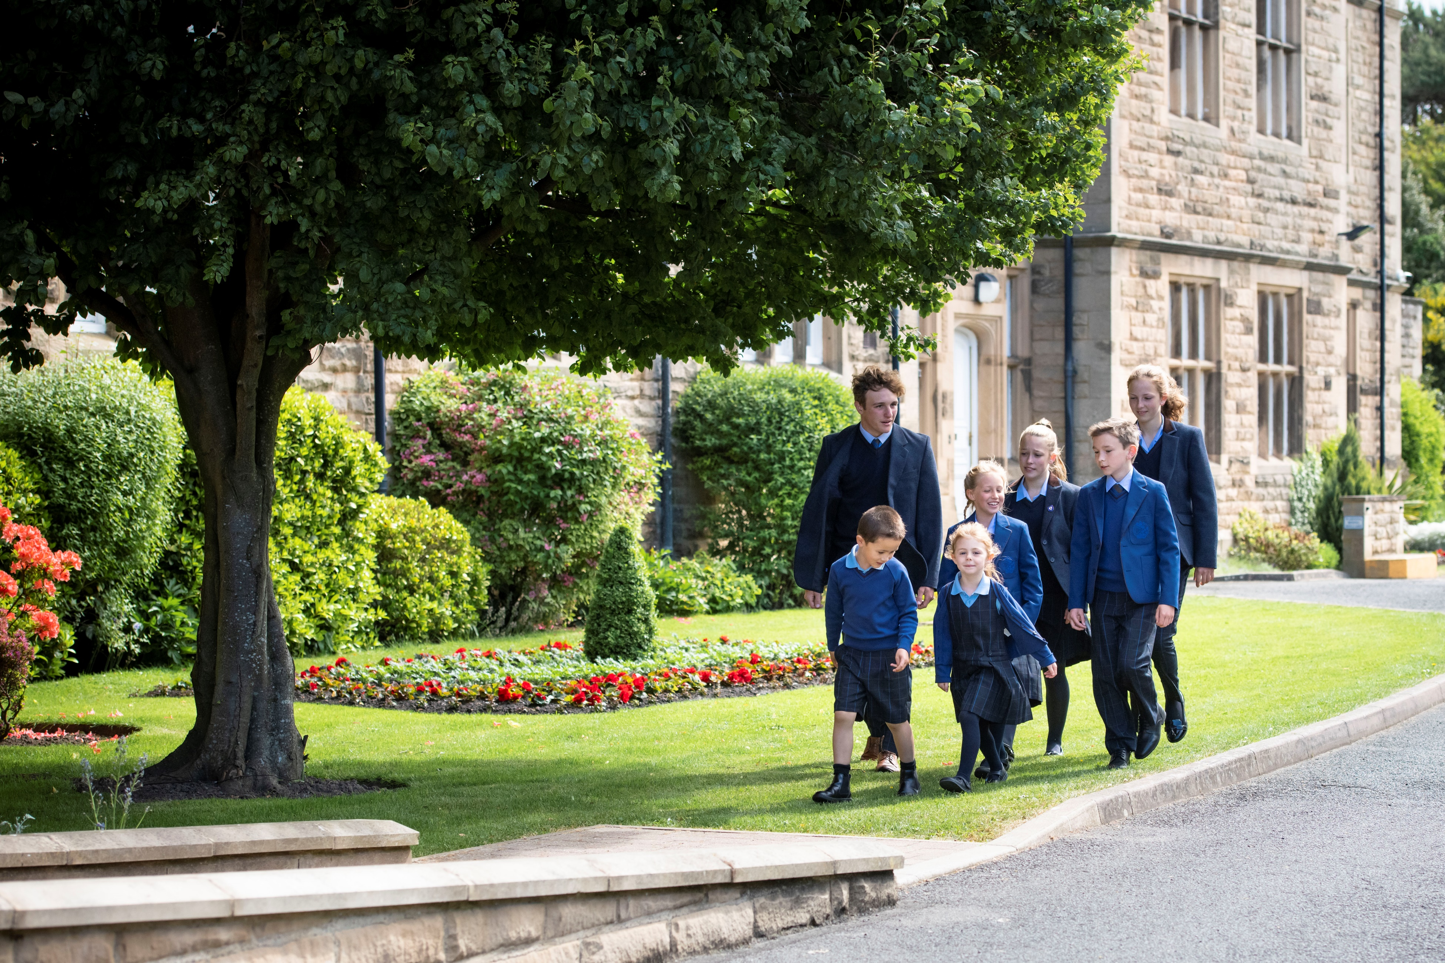

BARNARD CASTLE SCHOOL | BARNARD CASTLE | COUNTY DURHAM DL12 8UN | UNITED KINGDOM

Job Description

Job Title:
SENCO – Academic Learning Support (Whole School)
Reporting to:
DEPUTY HEAD (ACADEMIC)

Brief:
We are looking for a committed and experienced SENCO to provide support and guidance to pupils, parents and staff. Ensuring an ethos of inclusion across the School whilst supporting a culture of high aspirations for pupils receiving Academic Support at Barney. The successful candidate needs to be willing to work across the whole school.

Overall expectation
- To set the strategic direction for the development of the Academic Support Department.
- To promote excellent teaching and learning throughout the Department and with all teaching staff.
- To promote the widest possible access to the curriculum for all pupils.

Key Areas of Responsibility
- Strategic Direction and Development
- To ensure that all staff are aware of and understand pupils’ needs, so that all pupils’ can make progress. This includes developing a relevant programme of CPD.
- To ensure that there is a rigorous and accurate assessment process for identification of need.
- To have oversight over all SEND interventions, ensuring that they directly target student needs. This includes access arrangements.
- To manage the effective deployment of staff and resources to support pupil progress.
- Contribute to curriculum planning to ensure that it reflects the needs of pupils with SEND.

- Teaching and Learning
- To establish, maintain and develop high quality teaching within the department.
- To lead Review and Development process for members of the Department, setting high quality.
- To analyse results and to review support in the light of those results.
- To be forward thinking and innovative, providing guidance and training within the Department and to the whole School to ensure pupils are supported effectively.
- Undertake training and CPD to improve and maintain a well-rounded knowledge of SEND provision to ensure duties can be effectively performed.
- To communicate strategies to best support pupils with all members of staff.
- Monitor teaching and learning activities to ensure that they meet the specific needs of pupils with SEND.
- Promote a safe and secure learning environment for pupils with SEND, and action improvement plans where necessary. Provide professional guidance to staff to secure good quality teaching for pupils with SEND.
- To manage and deliver the Certificate of Personal and Social Effectiveness qualification, including curriculum plans, assessment and moderation.

- Academic Administration
- The ability to carry out the assessments for exam access arrangements.
- To work with the Exams Officer by helping to organise, schedule and invigilate access arrangements.
- To establish and promote departmental policies, in line with legislation and school policies in collaboration with the Deputy Head Academic.
- To maintain the register tracking system and up to date records for all pupils on the SEN profile.
- To analyse attendance, progress, and behaviour data each half-term for pupils on SEND profile.
- To manage and arrange the appointments for external services to meet with pupils and families. E.g. Educational Psychologist, Speech and Language Therapist.
- To ensure effective communication/consultation as appropriate with the parents of pupils.
- Providing and maintaining relevant communication links with medical, social and other external agencies e.g. CAMHS (Children Adolescent Mental Health Service).
- To support the organisation of review meetings as appropriate ensuring all external agencies and relevant staff are invited. Preparing paperwork as appropriate and updating documents where required. Provide regular progress updates to the Head and SLT
- To advise the Headmaster on the requirement and appointment of new staff.
- Provide clear channels of referral for staff to raise concerns about a pupil.
- Maximise opportunities for pupil voice for those with SEND.
- Liaise with the Academic Support coordinator in Prep School.

Expectations as a member of Barnard Castle School Common Room
- To have high professional standards and so be an appropriate role model of reliability, behaviour and appearance.
- To relate to pupils in an atmosphere of trust, frankness and ambition and to engender a climate of mutual respect.
- To make sure that pupils meet the School’s expectations of them.
- To facilitate the development of children’s confidence, self-esteem, determination, responsibility and personal pride in achievement, behaviour and appearance.
- To understand that offering a well-rounded education means engaging beyond the classroom, and therefore contributing to the wider life of the Barney education.
- To contribute to marketing the School and to promote the School to prospective pupils and parents.
- To establish and maintain high standards of communication with pupils, staff and parents.
- To uphold all the policies of Barnard Castle School.
- To take an interest in how the School functions and to convey suggestions for improvement to the Head of Department, Senior Management Team and Headmaster from time to time.
- To subscribe to the Common Room’s ethos of inclusivity, collegiality and helpfulness.

This job description reflects the present requirements of the post and is not intended to be exhaustive. Teachers may be required to carry out such other duties as the Headmaster may reasonably require from time to time.

Duties and responsibilities, may be subject to change and development, the job description will be reviewed periodically and subject to amendment in consultation with the post holder.

Support

The Teacher will be appraised by the Deputy Head (Academic) and will also have a review with the Headmaster but routine communication will be on going. Professional development is encouraged and will be discussed as part of the Teacher’s Review and Development cycle.

In order to meet the high standards expected of a teacher in our School, the Headmaster is seeking to employ a person with the following qualities, experience, skills and abilities.

Essential Criteria:
- A good honours degree.
- Evidence of being an excellent teacher.
- Qualifications in relevant areas of Academic Support.
- Leadership qualities, including energy, resilience and the ability to enthuse and motivate others.
- A record of and commitment to continuing professional development.
- Clear and effective communication skills in different media.
- A good understanding of effective teaching, learning and assessment in relation to raising pupils’ attainment.
- An ability and willingness to make a significant contribution to the extra-curricular life of the School.
- An ability to relate well to colleagues and children.
- Approachability, accessibility and flexibility.
- High levels of organisation.
- Experience with working a range of special educational needs.
- Up to date working knowledge of SEND code of practice and other relevant legislation.

Desirable Criteria
- A higher degree or experience of educational or subject-specific research.
- The ability to develop and maintain effective relationships with all members of the school community and outside agencies.
- Knowledge of the requirements and operation of ISI and the Equality Act in terms of Learning Support.
- Sympathy with the Christian values of the School and the nature of working in a boarding environment.
- Evidence of leadership and management of people, resources, innovation and improvement.
- Evidence of good management, which incorporates detailed planning, successful implementation and effective monitoring and evaluation of strategies.

BARNARD CASTLE SCHOOL | BARNARD CASTLE | COUNTY DURHAM DL12 8UN | UNITED KINGDOM

Recruitment Process
If you feel that you can meet the above requirements then please submit a letter of application along with the Barnard Castle School application form to the Headmaster. Only applications containing the requested information will be considered.
Applications should be sent to:
Mr A C Jackson
Headmaster
Barnard Castle School County Durham
DL12 8UN
Phone 01833 696098
Fax 01833 638985

E-mail hr@barneyschool.org.uk
Closing Date
Wednesday 9th February – 9.00am
Interviews
Week commencing Monday 22nd February

Barney Application Process:

Information about Interviews:

Applicants should read carefully the application procedure – guidance for applicants, Policy on the Recruitment of Ex-offenders and the Disclosure policy and the Safer Recruitment policy.
Barnard Castle School is committed to safeguarding and promoting the welfare of children and young people and expects all staff and volunteers to share this commitment. This post is exempt from the Rehabilitation of Offenders Act 1974 and all applicants will undergo child protection screening, including checks with past employers and an enhanced DBS and Barred list check with Disclosure and Barring Service.
Barnard Castle School is an equal opportunities employer.

BARNARD CASTLE SCHOOL | BARNARD CASTLE | COUNTY DURHAM DL12 8UN | UNITED KINGDOM

WWW. B ARNARDCASTLESCHOOL.ORG .UK

