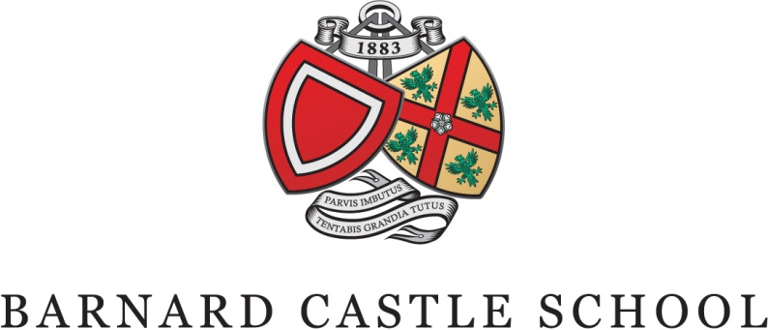

JOB DESCRIPTION
Title: | General Catering Assistant (GCA)
Responsible to: | Catering Manager (in their absence Head Chef)
Reporting to: | GCA Team Leader
Department: | Support – Catering

Hourly Rate: National Minimum Wage | Hours per week: 37

Purpose: | The purpose of the role is to support the Catering Manager and Head Chefs in ensuring the delivery of the highest quality food service during term time. service.
Duties : | General  - To be responsible for the efficient delivery of a high quality, customer-oriented food production service which meets the needs of the pupils, staff and visitors to the school and maintains departmental standards.  - Supporting the delivery of catering and hospitality for functions and events.  Specific  - To ensure the dining room is ready for use at the appropriate times for meals, break time, sports teas and functions.  - To ensure the dining room is cleaned and setup after each meal.  - To ensure the service areas, counters and hot cupboards are cleaned after each meal.  - To serve on the hotplate at meal times.  - To work in the plate wash area at meal times.  - To tidy and clean the plate wash area and ensure the removal of all waste.  - To transport food and other supplies as requested.  - To fill in and complete all paperwork when required (e.g. cleaning schedule, delivery notes)  - To serve at morning break and controlling the issue of snacks.  - Maintain the highest standards of health, hygiene and safety.  - To immediately report all accidents, near misses, damage or breakages to the Catering Manager.  - To actively assist in ensuring a five star food hygiene rating.  - To ensure that the Catering Department is opening and closed at the required times and secured when not in use.  - To undertake any other tasks appropriate with the duties and responsibilities of the post  - To attend any relevant training sessions to ensure that you are fully equipped to perform your role effectively

Person Specification
Essential Requirements: | Desirable Requirements:
- Ability to carry out all aspects of the role to a high standard at all times  - Excellent social and verbal communication skills  - Positive attitude  - Approachable and flexible.  - A common sense approach.  - Must be able to work on own initiative, and with resilience.  - The ability to organise workload and multi-task.  - The ability to work without direct supervision.  - The ability to work as a member of a team  - Excellent attendance and punctuality  - Highly motivated with a drive to introduce continuous improvement.  - Reliable | - NVQ level 1/2 in Catering & Hospitality  - Certificate in food hygiene training  - Certificate in First Aid.  - Certificate in Health and Safety including Knowledge of COSHH regulations, safe storage and working practices  - Experience of delivering a catering service in a high volume environment.  - Experience of working in a boarding school or residential environment.  - An awareness of child protection and safeguarding procedures/ The Children’s Act  - An understanding of Keeping Children Safe in Education.  - An awareness of National Minimum Standards in Boarding.

Minimum Training
The following training courses are considered to be a minimum requirement for the post and will be planned as appropriate to support the role, responsibilities and duties undertaken: -

- Health and safety
- Fire safety awareness
- Food Hygiene
- Child protection and safeguarding

All employees of Barnard Castle School (BCS) are expected to:-
- Actively follow, uphold and promote BCS policies, in particular equal opportunities, fire, health and safety and safeguarding.
- Be responsible for considering the Health and Safety of themselves and others as an integral part of their job.
- Maintain an awareness and observation of fire regulations
- Undertake safeguarding training and understand safeguarding obligations
- Carry out any other duties as are within the scope, spirit and purpose of the post as requested by the line manager/SMT
- Demonstrate their ongoing commitment to delivering the highest standards through their department’s delivery of service.
- To establish good standards of communication with all stakeholders
- To take an interest in how the School operates
- To be an appropriate role model of reliability, behaviour and appearance.

Barnard Castle School is committed to safeguarding and promoting the welfare of children and young people and expects all staff and volunteers to share this commitment.

Applications
If you feel that you can meet the above requirements then please submit a letter of application along with the Barnard Castle School application form to:-

Mrs Margaret Alderdice
Bursar’s PA
Barnard Castle School
County Durham
DL12 8UN

Phone: 01833 696098
E-mail: hr@barneyschool.org.uk

Please note applications will be considered as they arrive.
Applicants may telephone to discuss matters relating to the advertised post with the Catering Manager.

Ms Jacquelene Notman
Domestic Services and Catering Manager
Barnard Castle School
County Durham
DL12 8UN

Phone: 01833 696064
E-mail: jn@barneyschool.org.uk

Applicants should carefully read the application procedure – guidance for applicants, Policy on the Recruitment of Ex-offenders and the Disclosure policy and the Safer Recruitment policy.

Barnard Castle School is committed to safeguarding and promoting the welfare of children and young people and expects all staff and volunteers to share this commitment. This post is exempt from the Rehabilitation of Offenders Act 1974 and all applicants will undergo child protection screening, including checks with past employers and an enhanced DBS and Barred list check with Disclosure and Barring Service.

Barnard Castle School is an equal opportunities employer.

Last updated: October 2021 | Name: Margaret Alderdice

