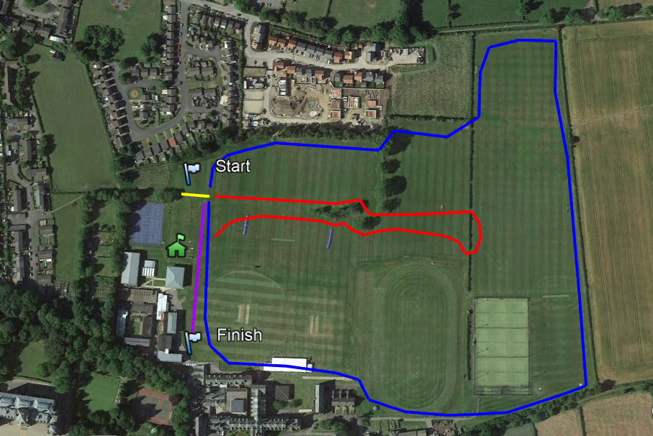

**SWDSAA District Cross Country Championships 2021**

**Barnard Castle School Thursday 18 November 2021 12.00 - 13.45**

**Race order:**

**Inter Girls 12.00 – 2.5 km or 1.5 miles (Red + Blue)**

**Inter Boys 12.20 - 4.1 km or 2.6 miles (Red + Blue + Blue)**

**Junior Girls 12.40 - 2.5km or 1.5 miles (Red + Blue)**

**Junior Boys 13.00 – 2.5 km or 1.5 miles (Red + Blue)**

**Presentation 13.30**

**SOUTH WEST DURHAM SCHOOLS’ ATHLETICS ASSOCIATION**

**CROSS COUNTRY CHAMPIONSHIPS**

**2021**

**BARNARD CASTLE SCHOOL**

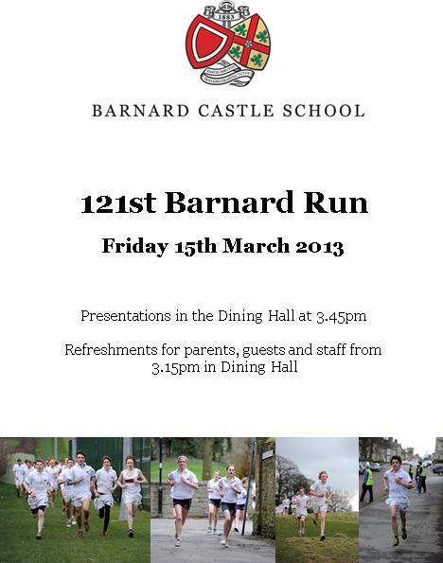

|  |
| --- |
| **Barnard Castle** |
| **Bishop Barrington**  **Greenfield** |
| **King James** |
| **Parkside** |
| **Sedgefield** |
| **St. Johns** |
| **Staindrop** |
| **Teesdale** |
| **Wolsingham** |
| **Woodham** |

**Junior and Intermediate**

**Boys and Girls**

**Teams of 10 with 6 to count**

**First 16 qualify for the County Championships**

**Durham County Schools’ Cross Country Championships**

**12.30 Saturday 15 January 2022**

**Barnard Castle School**

**Inter County Championships, 12.00 Saturday 5 February 2021**

**Cleveland**

**For all County athletics and cross country go to the County website https://dcsaa.co.uk/**

**Welcome to Barnard Castle School**

**Parking**

Pupils to be dropped off at the top of the school drive. Coach parking is available in the bus lane on the school drive with overflow parking behind the Bowes Museum on Crook Lane. There is parking next to the M-Block for minibuses by prior arrangement. Visiting parents should park on the school drive or at the Bowes Museum.

**Toilets**

Toilets are available in the A-Block for athletes and the main school for parents and guests.

**On arrival**

Teams to be walked up the school drive towards the M-Block and tennis courts. Team managers to report to the race desk to collect recording envelopes and to make team declarations. All athletes should assemble on the grass behind M Block until their race is due to start. It is the responsibility of team managers and the athletes themselves to get to the start in good time. Listen out for the starter’s instructions. Athletes should be familiar with the course, but it will be clearly marked.

**Finish area**

Athletes should hand their finishing position tag to their team manager.

Completed results envelopes to be taken to the results office in M-Block without delay.

**Refreshments**

Refreshments are available for parents, visiting staff and athletes in the finish

area. Please use the bins provided for litter.

I would like to take this opportunity to encourage athletes to join a local running club or register with ParkRun – a completely free 5-k timed run



**Charles Alderson**

**Race organiser**